Improving 3D Shape Recognition withElectrostatic Friction Display

【Content】:

Can users recognize 3D features (such as bumps) only from electrical vibration feedback without any visual information.

【Apparatus】:

In this study, we used a Feelscreen development kit (Senseg, Finland) as the electrostatic friction display, which com-prises an electrostatic ﬁlm overlaid on a commercial tablet (Google Nexus 7). Its software development kit (SDK) sup-ports nine haptic effects (called haptic grains) that provide noticeably different friction patterns.

【Experiments】：

**E1:**

To characterize the dynamic behavior of the Feelscreen device, we used a ruled scanning surface as shown in Fig. 2a. Whenever the touch pen, rotating along the dashed circular path, crossed one of the straight lines, electrovibra-tion was activated. In each trial, we collected 20 seconds of data and then applied a Butterworth band-pass ﬁlter with a low cut-off frequency of 10 Hz and a high cut-off frequency of 500 Hz. Fig. 2b shows an example of tangential force col-lected from a haptic grain named EDGE-SOFT (provided in the Feelscreen SDK) with the maximum intensity of 1.0. It also reveals that whenever a line was crossed by the touch pen, a vibratory tangential force occurred with a peak-to-peak (p-p) amplitude as large as 0.25 N.

We then identiﬁed the relationship between input inten-sity and the magnitude of output tangential force. For each intensity between 0.1 and 1.0 (step size 0.1), we collected force data and applied the same band-pass ﬁlter. We computed the p-p amplitude of the tangential force and then averaged the 50 largest values. The mean p-p amplitude showed a quadratic relationship to the input intensity, as shown in Fig. 2c (haptic grain EDGE-SOFT). Assuming the internal ampliﬁcation unit of Feelscreen has a constant gain, the rela-tionship between its input (grain intensity) and output (volt-age applied to the electrostatic ﬁlm) should be be linear. Based on this assumption, the obtained result conforms to the classic theory of electrovibration that the output force magnitude is in proportion to the square of input voltage [8].

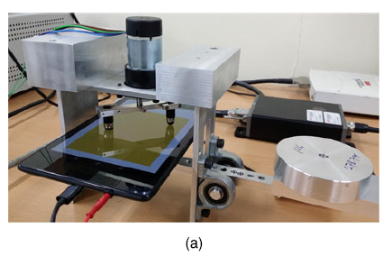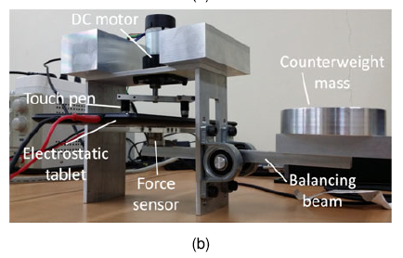

**E2:**

We also looked at the static behavior of friction force using a different Android application rendering a circular scanning surface (Fig. 3a) The circular surface was divided to eight equal circular sectors, and the EDGE-SOFT haptic grain was enabled for only one circular sector (number 4, highlighted red in Fig. 3a) and disabled for the other sectors. For measurements, the touchpen was rotated on the surface by our tribometer.

An exemplar plot of ﬁltered lateral forces is given in Fig. 3b. We also computed average forces when electrovi-bration was on and off (black line in Fig. 3b) and used their difference to represent the increase of static friction force. This procedure was repeated for each input intensity between 0.1 and 1.0 (step size). The average increases of static friction force are shown in Fig. 3c as a function of input intensity. The relationship was quadratic again, as was for the vibratory friction force.

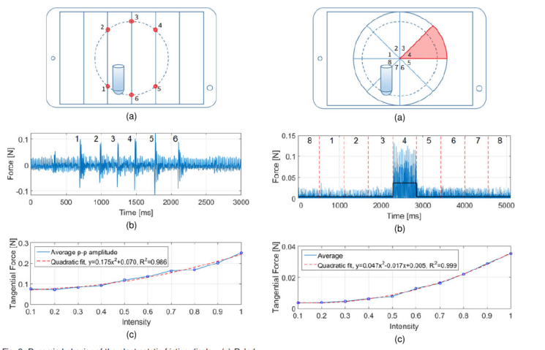

**E3: (User Study)**

This formative user study aimed to assess how well users can recognize primitive 3D geometrical shapes when pro-vided with depictions of the shapes by the friction force pro-duced by an electrostatic display. A similar method was also implemented using a force-feedback haptic interface for inclusion in the experiment as the baseline.

Design:

For each device, the experiment consists of two parts. Part 1 is a public explanation; after exploring each stimulus, participants were asked to freely describe their opinions and writing experiences. Participants were not provided with anything that could bias their views. The second part is a closed question. For each stimulus, participants were asked to choose one of four answers: 1) collision, 2) hole, 3) flat surface, and 4) none of these. Instruct them to choose the shape that best describes their perception. Perform Part 1 first, then use the same equipment for Part 2 after a short break.

Conclusion:

First, if no guidance or context is suggested that is associated with the geometric shape, the user cannot recognize the original 3D feature by electrical vibration alone. Second, when giving clues about the geometry, the user can correlate the electrical vibration pattern to the geometry much more than the opportunity level. However, the performance is lower than the best performance that the main power feedback can achieve.

【GENERALIZED GRADIENT-BASED LATERAL FORCE RENDERING ALGORITHM】Omitted

【Paper conclusion】：

Research shows that users cannot naturally associate electrical vibrations. 3D shaped graphics can have acceptable performance if given clear guidance without visual cue